CREATE OR REPLACE TRIGGER tri
AFTER INSERT ON customer_details
FOR EACH ROW
BEGIN
DBMS_OUTPUT.PUT_LINE('A row is inserted');
END;
/
INSERT INTO customer_details(cust_id,cust_name,address)
VALUES(1,'Anu','Kochi');
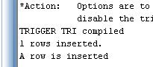
CREATE OR REPLACE TRIGGER trig
AFTER INSERT ON emp_details
FOR EACH ROW
WHEN (NEW.salary>20000)
BEGIN
DBMS_OUTPUT.PUT_LINE('salary is greater than 20000');
END;
/
INSERT INTO emp_details(empid,empname,salary)
VALUES(2,'Alen',30000);
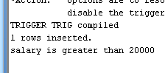
CREATE OR REPLACE TRIGGER trigg
BEFORE INSERT OR DELETE ON customer_details
FOR EACH ROW
BEGIN
IF DELETING THEN
UPDATE cust_count
SET count_row=count_row-1;
ELSE
UPDATE cust_count
SET count_row=count_row+1;
END IF;
END;
/

INSERT INTO customer_details VALUES(1,'Anu','Kochi');
DELETE FROM customer_details WHERE cust_id=1;

SELECT * FROM cust_count;
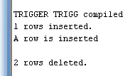
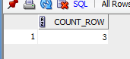

set serveroutput on
show serveroutput
CREATE OR REPLACE FUNCTION factorial(n INT)
RETURN INT IS
fact INT := 1;
BEGIN
FOR i IN 1..n LOOP
fact := fact * i;
END LOOP;
RETURN fact;
END;
/
DECLARE
result INT;
BEGIN
result := factorial(5);
DBMS_OUTPUT.PUT_LINE ('Factorial is ' || result);
END;
/

